Required Project 15.1: Creating a Books Web Application

- Provide two screenshots. One screenshot should show that you successfully installed the flask-restful library. One screenshot should show that you successfully installed the flask-jwt-extended library.

Installing flask and flask-restful.
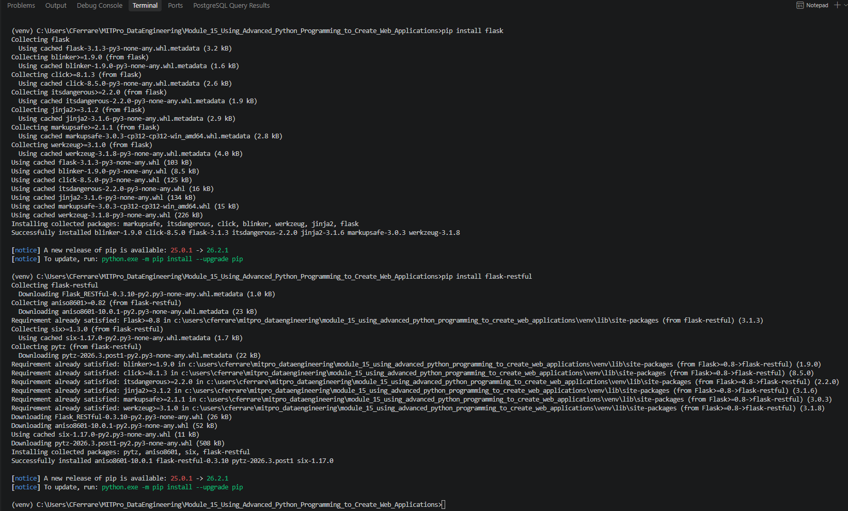

Flask-JWT-Extended install
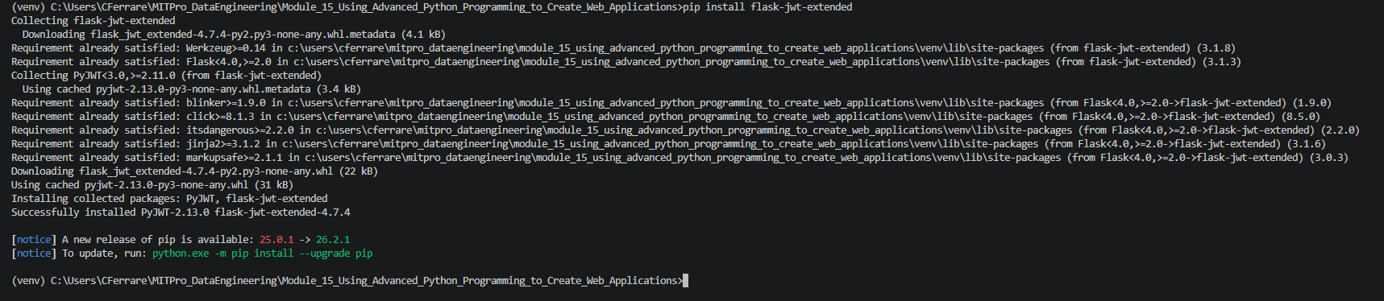

- Provide a screenshot to show that you successfully opened the Project 15.1 folder using VS Code.

Successfully extracted the starter files and saved in our module 15 project directory.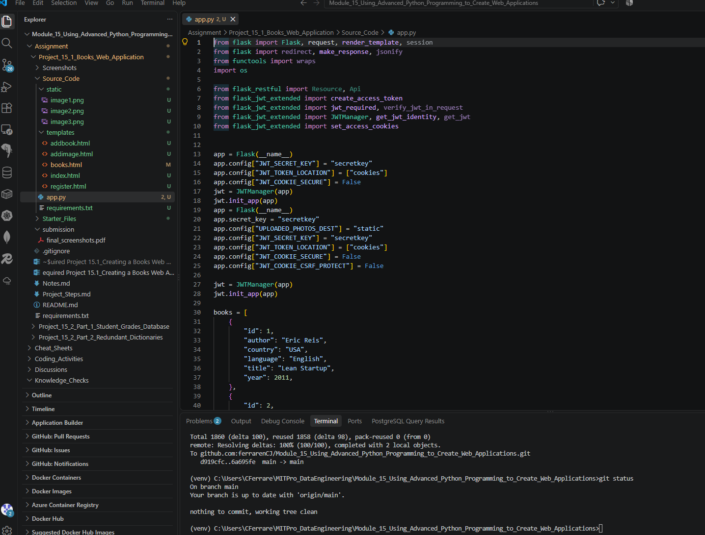

- Provide a screenshot to show that you successfully added two more books to the books list in the app.py file.
- Two books added
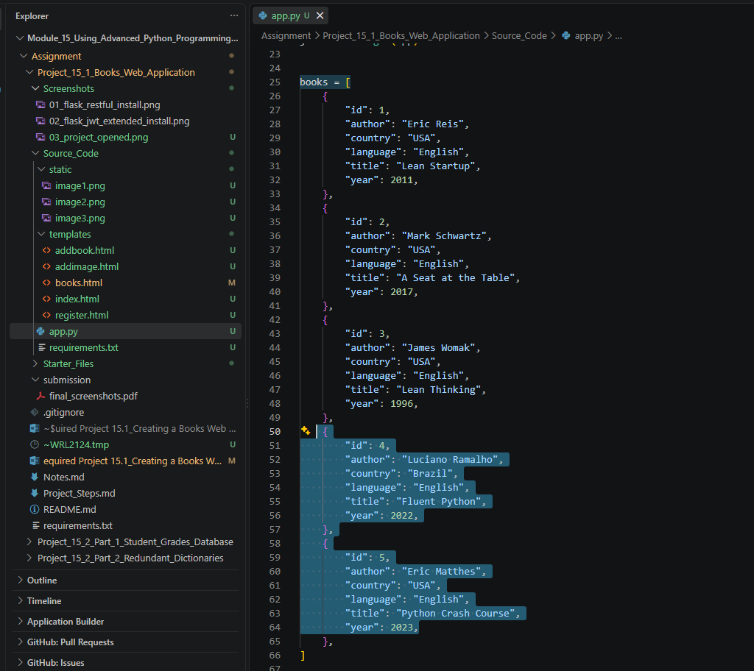

- Provide two screenshots, one for each new cover image, to show that you successfully uploaded and opened the new cover images in the static folder using VS Code.
4a - image4.png open in VS Code 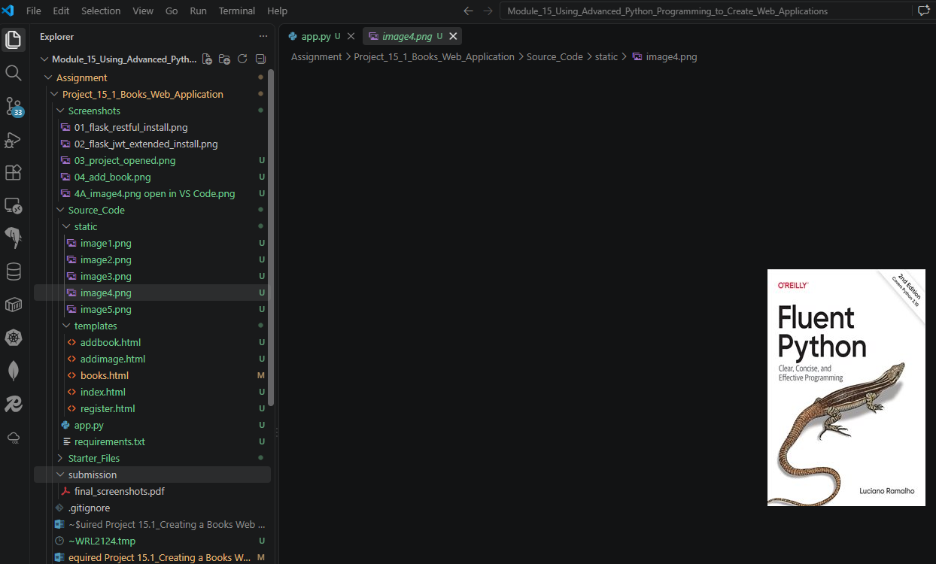

4B - image5.png open in VS Code
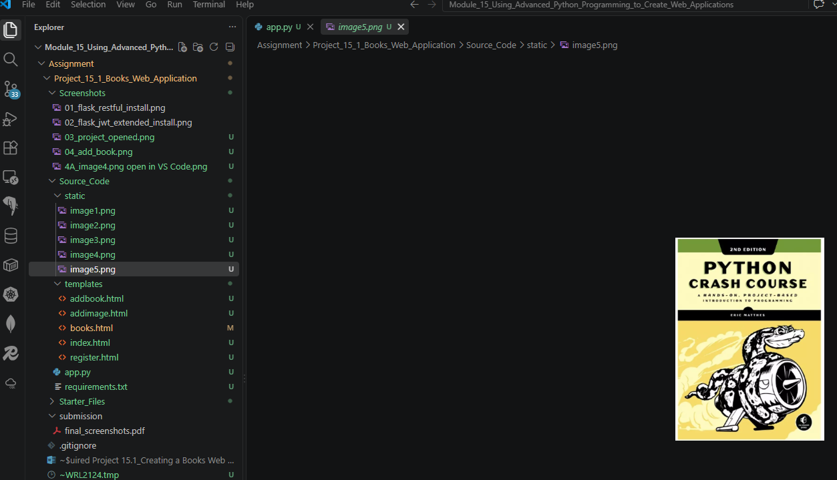

- Provide a screenshot to show that you successfully added the correct html line of code in the the books.html file.
- books.html updated
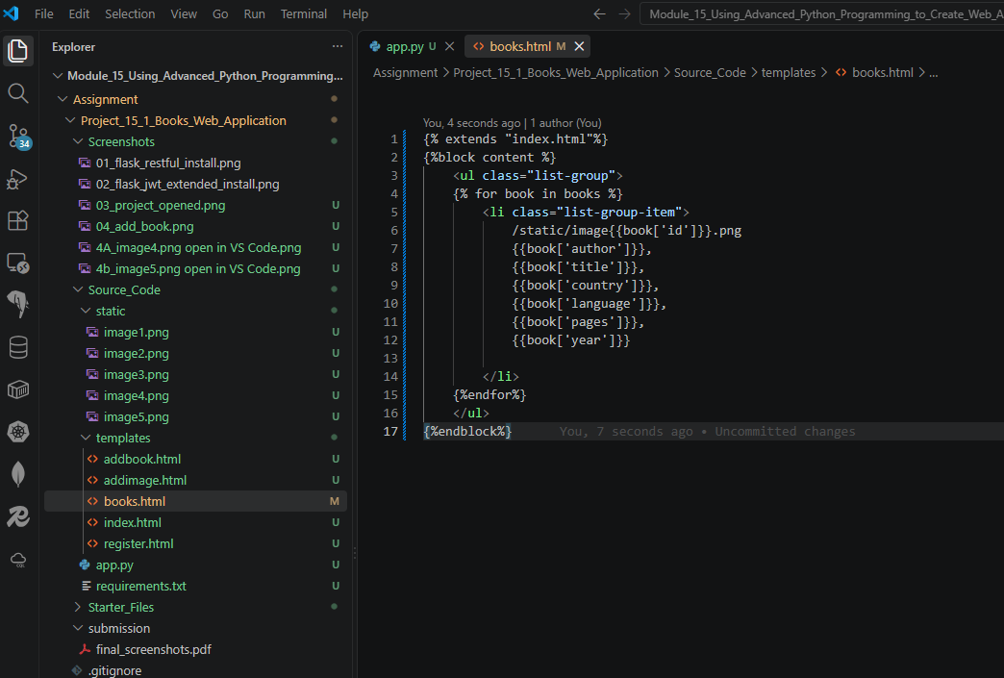

- Provide a screenshot to show that you successfully added two new users, one with the role of admin and one with the role of reader, in the app.py file.

- Users added
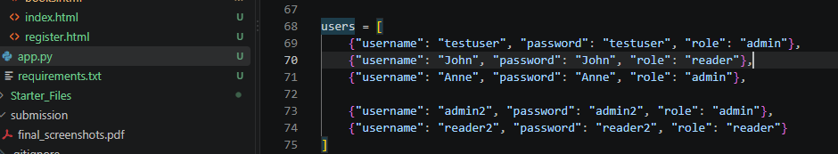

- Provide a screenshot to show that you correctly defined the admin_required(fn) function.

- admin_required() function
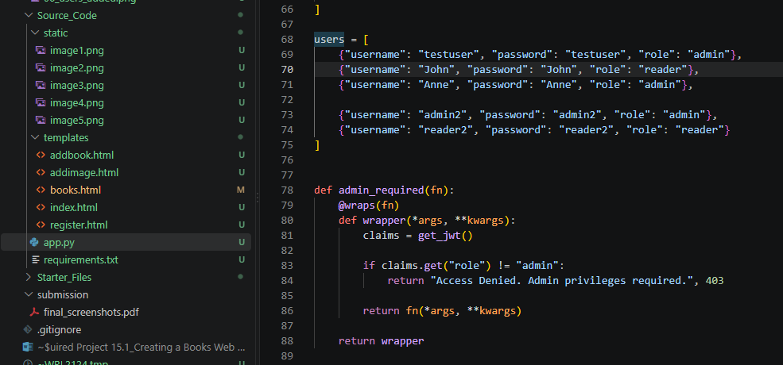

- Provide a screenshot of your Terminal window to show that your code ran correctly and successfully connected to localhost:5000.

- Localhost terminal running
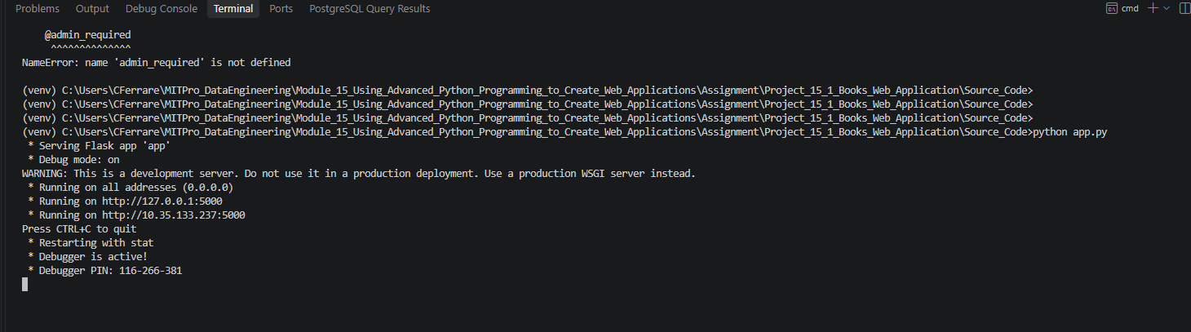

- Provide a screenshot of your browser window to show that you correctly opened the page localhost:5000/.

Localhost homepage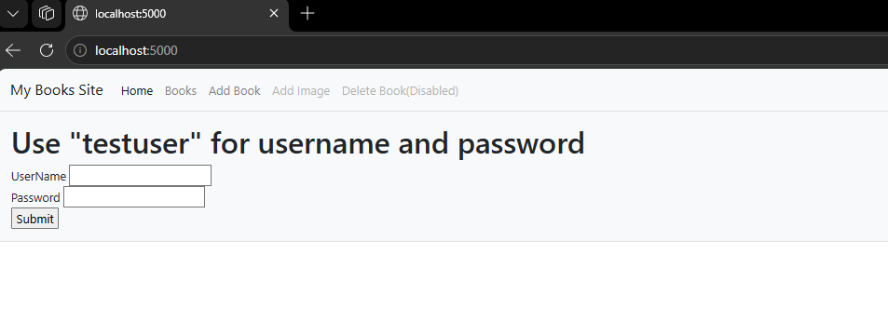
- Provide a screenshot to show that you successfully logged in as an admin.
Admin login
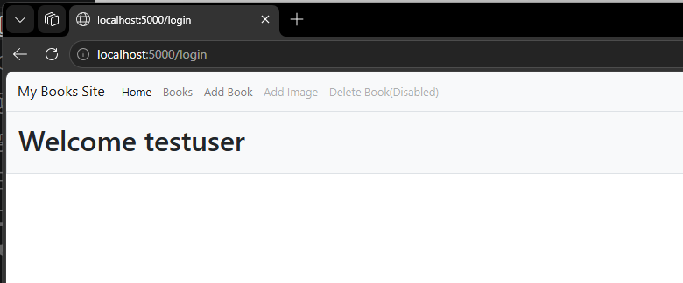

- Provide a screenshot to show that you can successfully see all the books defined in the app.py file along with their correct cover images in the “Books” tab.
- Books page with images

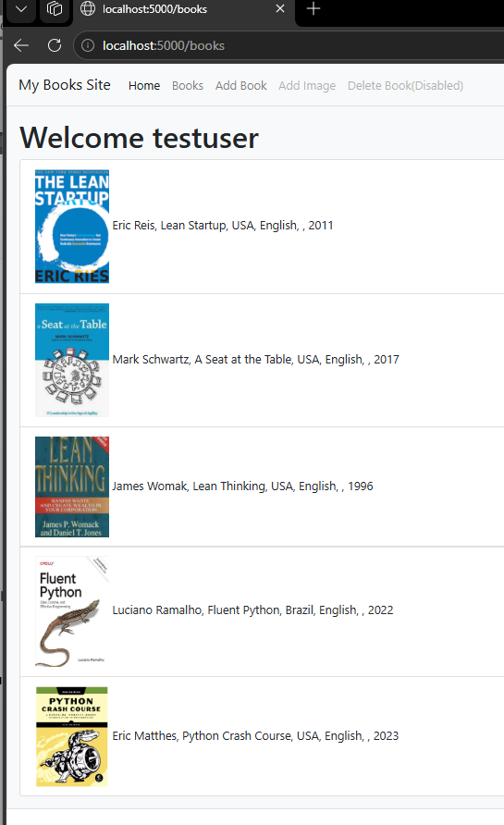

- Provide a screenshot to show that you can add a book using the “Add Books” tab.

Add book as admin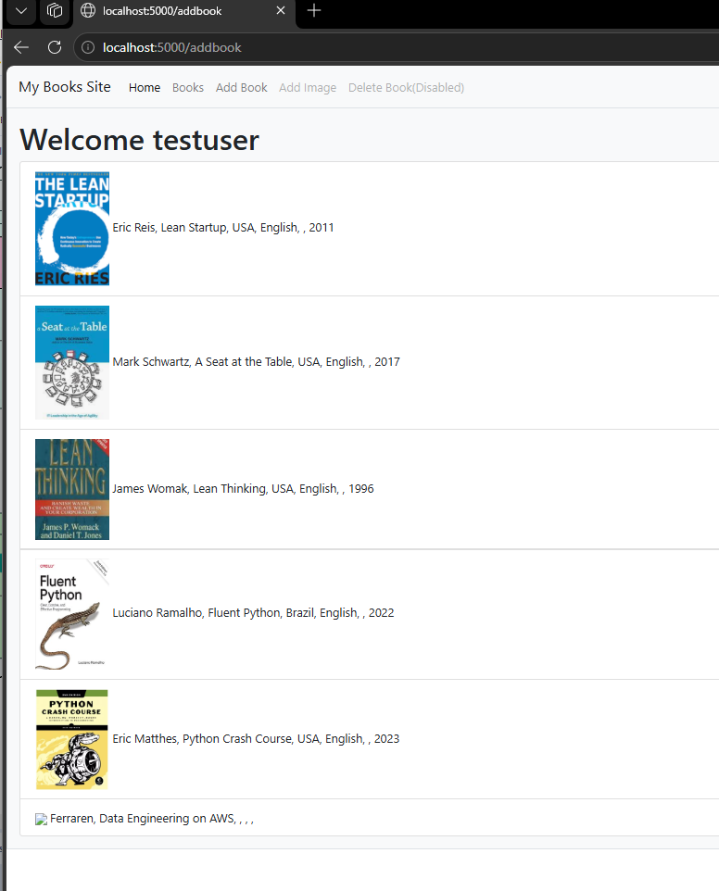

- Provide a screenshot to show that you successfully logged in as a reader.
Reader login
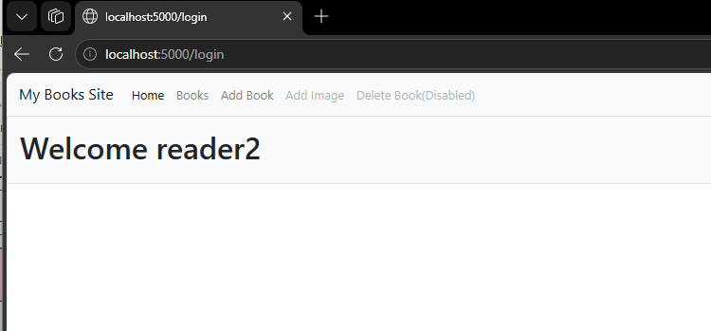

- Provide a screenshot of the error message to show that you can’t add a new book to your website using an account with only reader privileges.
Reader access denied
